Environmental disaster warning as oil spill reaches the Po, Italy's biggest river
Millions of litres released from oil depot in act of sabotage, officials say
guardian.co.uk, Wednesday 24 February 2010 17.33 GMT
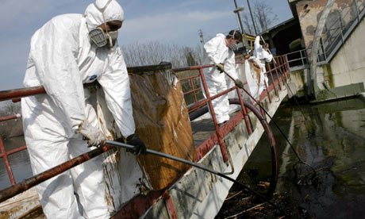
Workers clean up an oil spill on the Lambro river, a tributary of the Po, near Milan. The spill reached the Po, Italy's biggest river, today. Photograph: Tommaso Balestra/AP
An oil spill that fouled a tributary in northern Italy reached the Po river today, with officials warning of an ecological disaster as they scrambled to contain the sludge before it contaminated the country's longest river.
Milan regional officials said the cause was sabotage at a former refinery turned oil depot, since the cisterns were opened and the oil allowed to flow unimpeded into the Lambro river near Monza.
The cisterns "were opened by someone who was familiar with the plant and knew how to operate them," said Cinzia Secchi, a spokeswoman for the provincial government.
There were varying accounts of the amount of oil released: Secchi said officials now believed 2.5m litres (550,000 gallons) had poured out, down from an initial estimate of 10m litres, but significantly more than the 600,000 litres reported by the Ansa news agency and environmental groups.
Environmentalists said that several water and bird species were at risk from the spill. But the effects will last long after the clean-up as the Po valley is the most important agricultural region in Italy, and the river is used extensively for irrigation, the WWF noted.
The spill began yesterday in the 80-mile long Lambro and spread south to Piacenza and Cremona overnight, despite efforts to contain it. By today it had reached the Po, which crosses the country from Piedmont in the west, across Milan and Verona before emptying into the Adriatic.
"The scale of this is dramatic," Damiano di Simine, regional president of the Legambiente environmental group, said. He added that Legambiente and the regional government had asked that a state of emergency be declared to free up federal funds to help contain the spill.
"We don't yet know the details, but there is great damage to the ecological system – all the vegetation and fauna," he said.

